# ODE Modeling Exercises

## Exercise 5: ODE Model of Glycolysis

Imagine you were given the topology of a metabolic network and the values of all the parameters that you need. You should be able to create the in silico version of this system, simulate it and study it. The goal of this exercise is to formulate and implement a simple and abstract representation of Glycolysis of the bacterium *E. coli*, given its topology (Figure 1) and its parameters and initial conditions (Tables 2, 3).

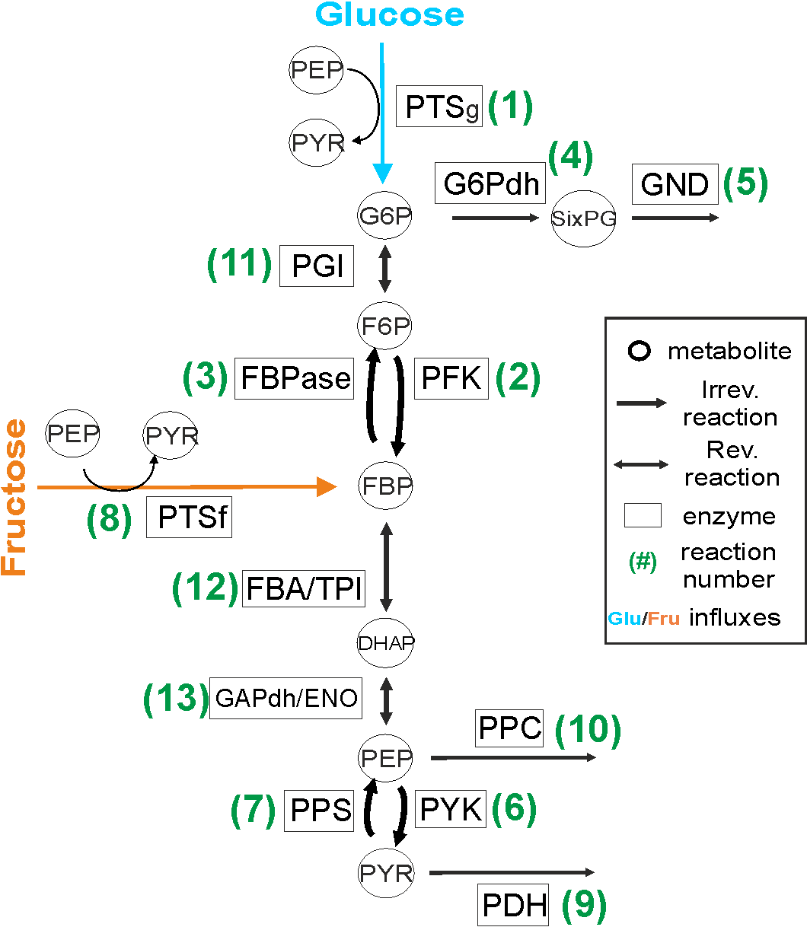

Figure : Reaction scheme of Glycolysis

**Pen and Paper Exercise: Set – up the reaction rates of the Glycolysis model**

1. Based on the reaction scheme in Figure 1 and the information and examples in Table 1, fill the gaps in Table 1 with reaction rates of the irreversible and reversible reactions. Irreversible reactions follow the Michaelis Menten law and reversible reactions follow the mass action law.

**Implementation and simulation of the Glycolysis model**

1. Using the provided Matlab file (CreateGlycolysisModel.m) as a basis, implement the ODE model of Glycolysis based on the reaction scheme in Figure 1 and the reaction rates in Table 1. The parameters (Vmax, Km) are given in Table 2. The initial concentrations of all the metabolites (species) are given in Table 3.
2. Simulate the dynamic behavior of the system in the case of growth on Glucose for **2, 10 and 40** seconds. Does the system reach a steady state after 2 seconds? Does the system reach a steady state after 10 or 40 seconds? Plot the simulated concentration changes of the metabolites from the **40 second** simulation in one graph. What are the steady state concentrations of the metabolites? Write them down in a table.

|  |  |  |  |  |  |  |  |
| --- | --- | --- | --- | --- | --- | --- | --- |
| Metabolite: | G6P | F6P | FBP | SixPG | DHAP | PEP | PYR |
| Concentration: |  |  |  |  |  |  |  |

1. Change the initial concentrations of metabolites G6P and FBP to the values that are provided in Table 4. Simulate the model for 40 seconds. Do the steady state concentrations of these metabolites change compared to the ones in question 3, and if yes what are their new values?
2. What would you expect to happen if instead of changing initial concentrations of metabolites, you changed the Glucose Influx values? To check this, restore the values of G6P and FBP to the initial values described in Table 3. Change the Glucose Influx value by changing the value of Vmax1 of the PTS enzyme to each of the values provided in Table 5. To make sure that the system reaches steady state, simulate the model for **100** seconds for every Vmax1 value. Plot the results. Do the steady concentrations of metabolites change? If yes, please provide these new steady state values for all metabolites in a table.
3. Based on the simulation results in questions 5, what happens to metabolite FBP when we increase Glucose Influx? Support your answer with a plot.
4. In this final part, simulate the model in the presence of a different nutrient (carbon) source, in particular Fructose. You have to **set Glucose Influx (Vmax1) to 0 mM/sec**, and consequently **set the Fructose Influx (Vmax8) to 1.8 mM/sec**. Simulate the dynamic behavior of the system in the case of growth on Fructose, for **40** seconds. Plot the simulated concentration changes of the metabolites in one graph. What are the steady state concentrations of the metabolites? Write them down in a table.

Table 1: Reaction rates of Glycolysis’ reactions

|  |  |  |  |  |
| --- | --- | --- | --- | --- |
| **Reaction #** | **Enzyme** | **Irreversible / Reversible** | **Reaction Rate** | **Comments** |
| 1 | (Glucose Influx) PTSg**\*** | Irreversible | $$Vmax1$$ | Done |
| 2 | PFK | Irreversible | $$Vmax2*\frac{[F6P]}{\left[F6P\right]+Km2}$$ | Done |
| 3 | FBPase | Irreversible |  | To be completed |
| 4 | G6PDH | Irreversible |  | To be completed |
| 5 | GND | Irreversible |  | To be completed |
| 6 | PYK | Irreversible |  | To be completed |
| 7 | PPS | Irreversible |  | To be completed |
| 8 | (Fructose Influx) PTSf**\*** | Irreversible | $$Vmax8$$ | Done, **it will be used in the last part of the exercise** |
| 9 | PDH | Irreversible |  | To be completed |
| 10 | PPC | Irreversible | $$Vmax10*\frac{[PEP]}{\left[PEP\right]+Km10}$$ | Done |
| 11 | PGI | Reversible |  | To be completed |
| 12 | FBA/TPI | Reversible | $$Vmax12forward*\left[FBP\right]- Vmax12backward*{[DHAP]}^{2}$$ | Done |
| 13 | GAPDH/ENO | Reversible | $$Vmax13forward*\left[DHAP\right]- Vmax13backward*[PEP]$$ | Done |

**\* These are “influxes” and for the purpose of this course we assume that they are known**

Table 2: Parameter values

|  |  |  |
| --- | --- | --- |
| **Parameter  (number corresponds to reaction)** | **Value** | **Unit** |
| Vmax1 **(Glucose Influx)** | 0.73 | mM / sec |
| Vmax2 | 2.58 | mM / sec |
| Vmax3 | 0.28 | mM / sec |
| Vmax4 | 0.31 | mM / sec |
| Vmax5 | 0.46 | mM / sec |
| Vmax6 | 3.16 | mM / sec |
| Vmax7 | 0.16 | mM / sec |
| Vmax8 (**Fructose Influx**, initially 0) | 0 | mM / sec |
| Vmax9 | 3.48 | mM / sec |
| Vmax10 | 1.52 | mM / sec |
| Vmax11forward | 11 | mM / sec |
| Vmax11backward | 10 | mM / sec |
| Vmax12 forward | 11 | mM / sec |
| Vmax12backward | 10 | mM / sec |
| Vmax13 forward | 11 | mM / sec |
| Vmax13backward | 10 | mM / sec |
| Km2 | 0.16 | mM |
| Km3 | 0.015 | mM |
| Km4 | 0.07 | mM |
| Km5 | 0.1 | mM |
| Km6 | 0.31 | mM |
| Km7 | 0.083 | mM |
| Km9 | 0.515 | mM |
| Km10 | 0.19 | mM |

Table 3: Initial values of species in mM

|  |  |
| --- | --- |
| **Species Name** | **Initial Value** |
| G6P | 3 |
| F6P | 0.07 |
| FBP | 0.16 |
| SixPG | 0.09 |
| DHAP | 0.849 |
| PEP | 0.563 |
| PYR | 0.81 |

Table 4: (Alternative) Initial values (mM)

|  |  |  |
| --- | --- | --- |
| **#** | **Species Name** | **Initial Value** |
| **1** | G6P | 0.03 |
| FBP | 0.001 |
| **2** | G6P | 0.01 |
| FBP | 4 |

Table 5: (Alternative) Glucose Influx values

|  |  |  |  |
| --- | --- | --- | --- |
| **#** | **Parameter Name** | **Value** | **Unit** |
| 1 | Vmax1 | 0.03 | mM / sec |
| 2 | Vmax1 | 0.55 | mM / sec |
| 3 | Vmax1 | 1.15 | mM / sec |
| 4 | Vmax1 | 2.10 | mM / sec |